





**Plantwide Applicability Limitations (PAL) Quick Guide Instructions for**

**Iowa EASY Air**

Iowa Department of Natural Resources

Wallace State Office Building

Air Quality Bureau

502 E 9th St

Des Moines, IA 50319

Phone: (515) 725-8200

**Contact the Iowa EASY Air Helpdesk**

**Email:** [**easyair@dnr.iowa.gov**](mailto:easyair@dnr.iowa.gov)

**Or call (515) 725-9569 or (515) 204-3749**

# Table of Contents

Table of Contents 2

List of Figures 2

1. Adding the Plantwide Applicability Limitations (PAL) Application to Your Account 3

2. Finding the Plantwide Applicability Limitations (PAL) Application 6

3. Filling Out and Submitting a Plantwide Applicability Limitations (PAL) Application 7

3.1 Form FI (Facility Information) 8

3.1.1 Facility Information 8

3.1.2 Permit Preparer Information 9

3.2 Form CP 9

3.3 Form AF 11

3.4 Attachments 12

3.5 Validation 13

3.6 Submission 14

# List of Figures

Figure 1 Dashboard Buttons to Create a New Submittal 3

Figure 2 Submittal Menu 3

Figure 3 Link to Submittal Types Associated with my Account 4

Figure 4 Available Submittal Types 4

Figure 5 My Account Menu 5

Figure 6 Basic Information Tabs 5

Figure 7 Associate Facility Button 5

Figure 8 Associate Facility Search 6

Figure 9 Facility Search Results and Adding Submission Type 6

Figure 10 Dashboard Buttons to Create a New Submittal 7

Figure 11 Submittal Menu 7

Figure 12 Construction Plantwide Applicability Limitations (PAL) Icon 7

Figure 13 Facility Name and Contact Person Summary 8

Figure 14 Equipment Location and Mailing Contact Summary 9

Figure 15 Application Cover Page Example Screen 9

Figure 16 SIC/NAICS Code Search Example 10

Figure 17 Form AF Screen 11

Figure 18 Attachment Screen 12

Figure 19 Attachment Screen 12

Figure 20 Example Attachment Screen 13

Figure 21 Example Validation Screen 14

Figure 22 Example Certificate of Submission Screen 14

Figure 23 Confirmation of Submittal 15

This document provides directions on how to apply for a Plantwide Applicability Limitation (PAL) in the Iowa EASY Air System. A PAL is useful only for sources that are already major for PSD purposes.

(Note: This document is written to explain how a Responsible Official can submit an application for a Plantwide Applicability Limitation (PAL). As with other submittal types within the Iowa EASY Air system, the Responsible Official may delegate the completion of these forms to a Preparer. The Preparer can complete the forms and have the Responsible Official complete the certification and submit the application. The instructions for assigning a Preparer for a facility and submittal type are covered in other parts of the Iowa EASY Air documentation.)

# Adding the Plantwide Applicability Limitations (PAL) Application to Your Account

Before you are able to apply for a Plantwide Applicability Limitation (PAL) in the Iowa EASY Air system, you will need to add the Plantwide Applicability Limitation (PAL) application to your account.

**Viewing Associated Application Types**

If you do not know what application types are associated to your account, you may navigate to the Air Department Submittal Type List page and view the submittal types associated with your account. There are two ways to the Air Department Submittal Type List page within the Iowa EASY Air system.

For one method, on your dashboard click on the “Apply for a New Submittal” button in the upper left-hand corner of the dashboard as shown in Figure 1.

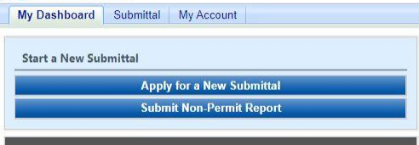

Figure 1 Dashboard Buttons to Create a New Submittal

Alternatively, hover over the Submittal dropdown menu and select “Start a New Submittal” as shown in Figure 2.

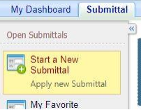

Figure 2 Submittal Menu

Next, you will see the application icons for the different types of submittals available to you in the system as shown in Figure 3.

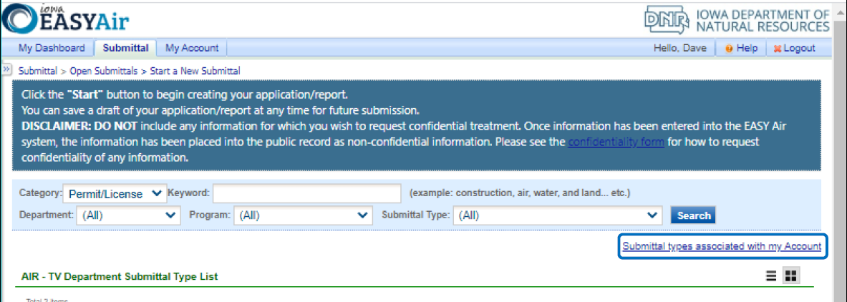

Figure 3 Link to Submittal Types Associated with my Account

Next, click on the link labeled “Submittal types associated with my Account” on the right side of the screen and the “Available Submittal Types” screen will appear as shown in Figure 4. On this screen, you are able to view the available submittal types and the submittal types already associated with your account.

A screenshot of the "Available Submittal Types". Two sections are shown, the "Available Submittal Types" and "Submittal Type Association Instruction".

Figure 4 Available Submittal Types

If you don’t see the Plantwide Applicability Limitation (PAL) application associated with your account, click on “Add More”. This will take you to the “Basic Information” page. Follow the instructions below to associate the application type.

**Associate an Application Type**

To associate an application type to your account, you will need to navigate to the “Associate Facilities” tab. To navigate to the “Associate Facilities” tab, on your dashboard hover on “My Account” and click on “Basic Information” as shown in Figure 5.

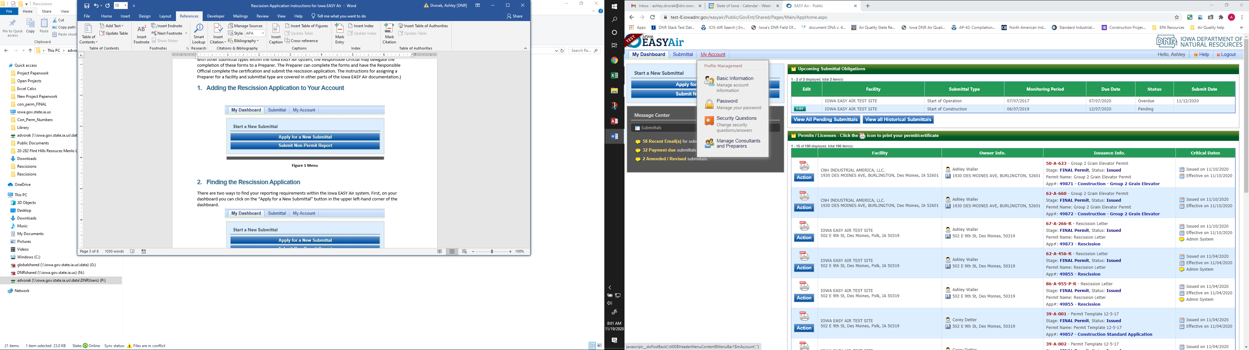

Figure 5 My Account Menu

The Basic Information page will appear. As shown in Figure 6, this page will have four tabs on top. Click on the “Associate Facilities” tab. This tab will show all your associated facilities and application types you currently have on your account.

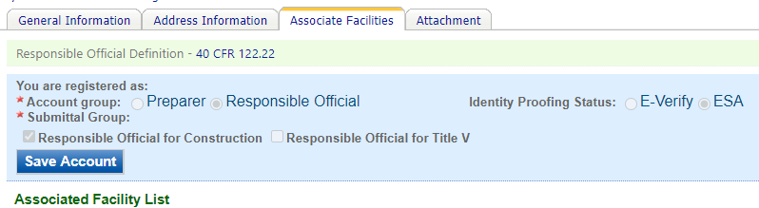

Figure 6 Basic Information Tabs

Next, scroll to the bottom of the page and you should see three buttons, as shown in Figure 7 below. Please click on “Associate Facility”.

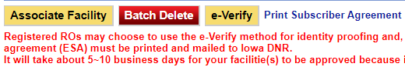

Figure 7 Associate Facility Button

The facility search will appear as shown in Figure 8 below. Enter in your facility information and click, “Search”. You may search by Facility Name, Address, or Facility Number.

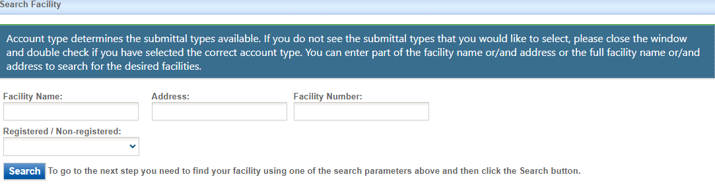

Figure 8 Associate Facility Search

The facility information will appear below the facility search as shown in Figure 9. Select the check box for the facility and the “Construction Plantwide Applicability Limitations (PAL)” check box under submission type.

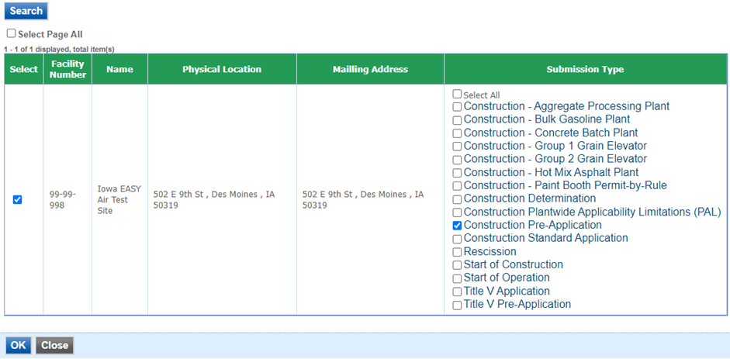

Figure 9 Facility Search Results and Adding Submission Type

Next, click “Ok” and then click “Close”. This will associate the Plantwide Applicability Limitations (PAL) application to your account. If you went through the e-Verify subscriber agreement process when you set up your account, you will be able to use the Plantwide Applicability Limitations (PAL) application after this step. However, if you sent in the paper subscriber agreement form, you will have to wait until the Iowa EASY Air Administrator completes the association of the Plantwide Applicability Limitations (PAL) application to your account. You will receive an email from the Iowa EASY Air Administrator when the association of the Plantwide Applicability Limitations (PAL) application has been made to your account.

# Finding the Plantwide Applicability Limitations (PAL) Application

There are two ways to start an application within the Iowa EASY Air system. For one method, on your dashboard you can click on the “Apply for a New Submittal” button in the upper left-hand corner of the dashboard as shown in Figure 10.



Figure 10 Dashboard Buttons to Create a New Submittal

Alternatively, hover over the “Submittal” tab and select “Start a New Submittal” as shown in Figure 11.



Figure 11 Submittal Menu

Next, you will see the application icons for the different types of submittals available to you in the system. The Construction Plantwide Applicability Limitations (PAL) icon is shown below in Figure 12. Please select “Start” at the bottom right hand corner of the icon to start the Plantwide Applicability Limitations (PAL) application.

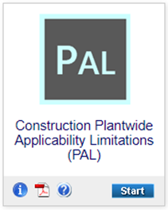

Figure 12 Construction Plantwide Applicability Limitations (PAL) Icon

# Filling Out and Submitting a Plantwide Applicability Limitations (PAL) Application

A plantwide applicability limitation (PAL) is an optional flexible permitting mechanism that involves the establishment of a plantwide emissions limit, in tons per year, for a regulated new source review (NSR) pollutant. A PAL represents a simplified NSR applicability approach that provides a source with the ability to manage physical and operational changes, and the impacts of those changes on facility-wide emissions on a per pollutant basis, without triggering major NSR or the need to conduct project-by-project major NSR applicability analyses. Each PAL is limited to one criteria pollutant. The facility does not have to have a PAL for all pollutants.

The added flexibility of a PAL allows a source to respond rapidly to market changes with reduced permitting burden and greater regulatory certainty. To qualify for these benefits, the PAL regulations require a source to conduct monitoring, recordkeeping, and reporting of the actual emissions of a PAL pollutant on a 12-month rolling total basis. PALs also serve air quality goals by creating an incentive for sources to control emissions more than might otherwise be required. PALs are different from construction permits issued by the Department in that they expire after 10 years, and must be renewed within timeframes specified by regulation.

## Form FI (Facility Information)

Next, the Form FI: Facility Information screen will appear (See Figure 13 and 14).

#### Facility Information

Please click on the “Company/Facility Name:” dropdown box and select the Company/Facility Name that the plantwide applicability limitation (PAL) permit should be completed for. The facility address, facility number, field office number, and current billing status will auto-fill. If the facility information is not correct, please contact [easyair@dnr.iowa.gov](mailto:easyair@dnr.iowa.gov) to change the facility information. All fields with a red asterisk are required to be filled in.

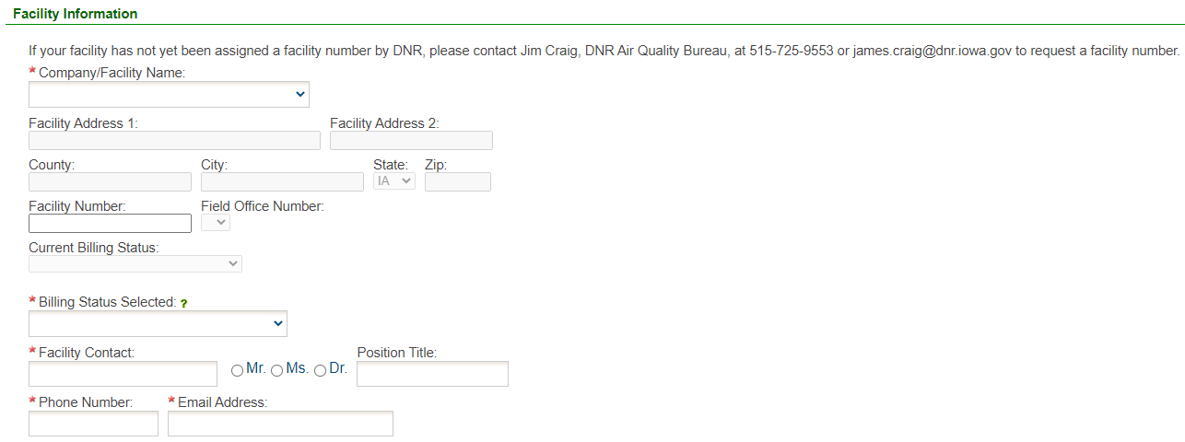

Figure 13 Facility Name and Contact Person Summary

The “Billing Status Selected:” field should be used to indicate the actual billing status for the facility if the “Current Billing Status” is incorrect. The Department will review and approve or deny your request once the application is submitted. If the “Current Billing Status” is correct, please select the same billing status under “Billing Status Selected”. If you have any questions about your facility’s billing status or Air Quality Fees, please visit the DNR webpage [Air Quality Fees](https://www.iowadnr.gov/Environmental-Protection/Air-Quality/Air-Quality-Fees).

Please provide the name, position title, and contact information for the person within the company who should be contacted regarding questions or other pertinent information related to the permit application.

Please provide the address for where the equipment at the facility is located. If the equipment is located at the same address as the facility, select the “Same as Facility Address” checkbox, and the information will be copied from the facility address information.

Please provide the name, position title, contact information, and mailing address for the person within the company who should be mailed the permit. If the person who should be mailed the final permit is the same person as the Facility Contact, select the “Same as Facility Contact” checkbox and the information will be copied from the facility contact information. If the mailing address for the person who should be mailed the permit is the same as the facility address, select the “Same as Facility Address” checkbox and the information will be copied from the facility address information.

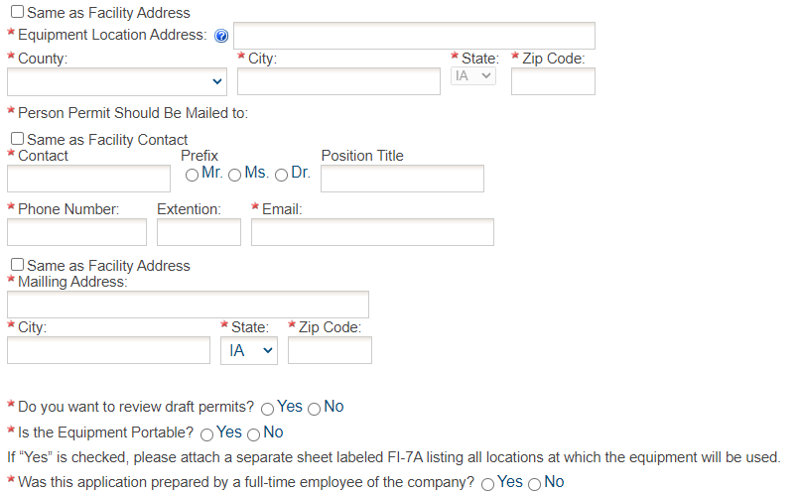

Figure 14 Equipment Location and Mailing Contact Summary

Indicate whether you would like to review the draft permits prior to issuance using the radio buttons for this question. Draft permits will be sent electronically to the email address of the Facility Contact person. A hard copy of the draft permit(s) will **not** be mailed.

Please note: The draft permits will undergo a 30-day comment period per Prevention of Significant Deterioration (PSD) guidelines.

#### Permit Preparer Information

If the application was prepared by a full-time employee of the company, please select the “Yes” radio button. If the application was not prepared by a full-time employee of the company, the permit preparer information must be filled out. Any permit preparer that is not a full-time employee of the company must be a licensed Professional Engineer (P.E.) in the State of Iowa (567 IAC 22.1(3)”b”). A P.E. signature document must also be attached to the submittal in the Attachments section. The P.E. number may be verified at the [License Search Page](https://iowaplb.force.com/LicenseSearchPage).

Once you have finished entering the information, click “Save” and then “Next”. If there is required information missing from the section, the Iowa EASY Air system will highlight the required fields in red. You may proceed with the application, but the system will not allow you to submit the application until all the required fields are completed during the Validation step.

## Form CP

Next, the Form CP (Cover Page) screen will appear (see Figure 15).

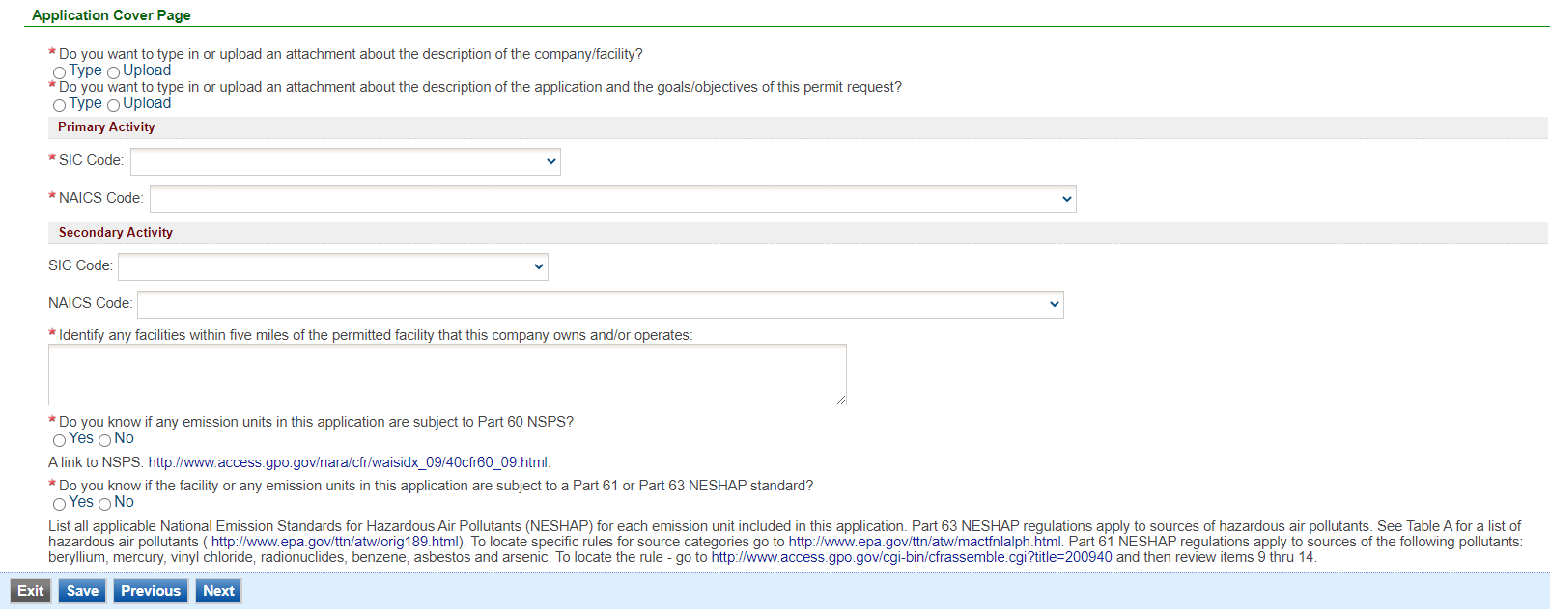

Figure 15 Application Cover Page Example Screen

Indicate whether you would like to either upload or type in a description of the company or the facility using the radio buttons. If you select “Upload”, the Company Description will become a required attachment at the end of the application in the Attachment screen. If you select “Type in”, the application will provide a text box to provide a description of the company/facility. Briefly describe the operations of your company. This description can include product(s) made and/or services provided, the company headquarters and size, subsidiaries of the company, and a website address for the company, etc. The purpose is to provide the review engineer with some background of the overall company.

Indicate whether you would like to either upload or type in a description of the application and the goals/objectives of the permit request using the radio buttons. If you select “Upload”, the Application Description will become a required attachment at the end of the application in the Attachment screen. If you select “Type in”, the application will provide a text box to provide a description of the application and the goals/objectives of the permit request. Please include the criteria pollutant(s) for which your facility is requesting a PAL.

**SIC and NAICS Codes – Industry Classification**

The Standard Industrial Classification (SIC) and North American Industrial Classification System (NAICS) codes are systems used for classifying industries and are used to determine a plant’s applicability to Federal regulations. Please provide the four-digit SIC and NAICS code(s) for your facility using the drop-down menus.

To quickly access a specific number: while clicking on the drop-down menu, begin typing the SIC code and the menu should quickly jump to that number, as shown in Figure 16.

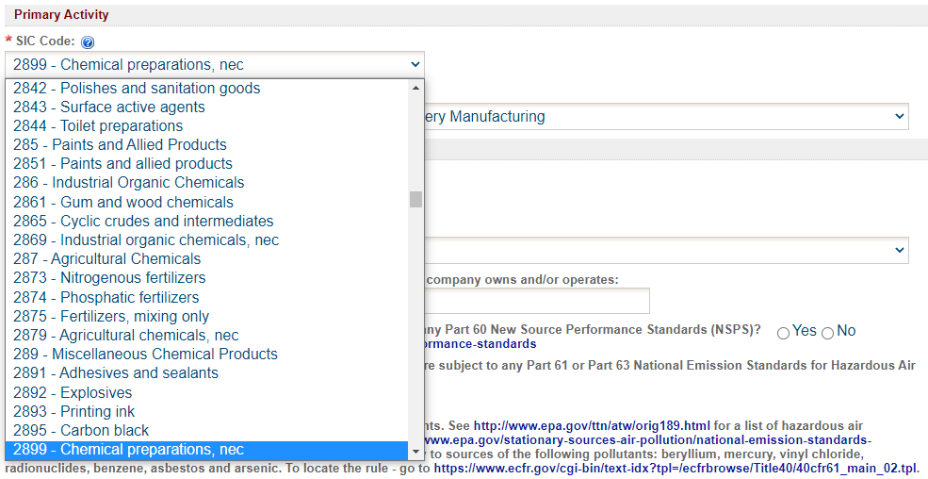

Figure 16 SIC/NAICS Code Search Example

SIC codes classify industries according to similarities in products, services, and production & delivery systems. The SIC Manual can be found at [OSHA SIC Manual](https://www.osha.gov/data/sic-manual) and a search for SIC codes can be found at [OSHA SIC Search](https://www.osha.gov/data/sic-search).

NAICS uses a six (6) digit hierarchical coding system to classify all economic activity into twenty (20) industry sectors. For more information on the conversion from SIC codes to NAICS codes go to [NAICS Association SIC to NAICS Crosswalk](https://www.naics.com/sic-naics-crosswalk-search-results/). A search for your NAICS code(s) can be found at [Census NAICS Search](https://www.census.gov/naics/).

The Primary Activity should refer to the determination of the activity in which the facility is primarily engaged. The first step in this process is to determine the facility’s activity (or activities), generally either a service or a product that “enters into commerce” (i.e. the service or product goes beyond the boundaries of the facility).

The Secondary Activity should refer to any other activities at the facility that are distinctly separate from the Primary Activity (either a service or product that “enters into commerce” in a different category than the Primary Activity) that has the lesser relative share of economic contribution (the sum of the value of production for manufacturing and value of receipts for services).

For example: a chemical manufacturing operation makes adhesives, the large majority of which are shipped off-site to customers with the remainder of the adhesives going to another activity of the facility; a plywood manufacturing operation, where all the plywood is shipped to customers. The two activities would be SIC group 28 for the chemical manufacturing operation part of the operation and SIC group 24 for the plywood manufacturing part of the operation. The primary activity would be determined by the activity (chemical manufacturing or wood product facility) that has the highest relative share of economic contribution.

Next, please provide any other facilities, branches, or divisions of the company located within five (5) miles of the facility in this permit application in the text box.

**NSPS and NESHAP Subparts**

Please indicate whether you know if any emission units in this application are subject to any Part 60 New Source Performance Standards (NSPS) using the radio buttons. NSPS are Federal Regulations that apply to a wide range of sources of criteria air pollutants that typically apply to new equipment. A comprehensive list of NSPS rules are listed at the [EPA NSPS](https://www.epa.gov/stationary-sources-air-pollution/new-source-performance-standards) website. If you indicate “Yes”, a text box will appear. Please enter the name of the emission unit(s) and the applicable NSPS Subpart(s) for the equipment that is included in the application.

Please indicate whether you know if the facility or any emission units in this application are subject to any Part 61 or Part 63 National Emission Standards for Hazardous Air Pollutants (NESHAP) standard using the radio buttons. Part 63 NESHAP regulations apply to sources of hazardous air pollutants. See the [EPA Initial List of Hazardous Air Pollutants with Modifications](https://www.epa.gov/haps/initial-list-hazardous-air-pollutants-modifications) website for a list of hazardous air pollutants. To locate specific rules for source categories go to the [EPA National Emission Standards for Hazardous Air Pollutants (NESHAP)](https://www.epa.gov/stationary-sources-air-pollution/national-emission-standards-hazardous-air-pollutants-neshap-9) website. Part 61 NESHAP regulations apply to sources of the following pollutants: beryllium, mercury, vinyl chloride, radionuclides, benzene, asbestos and arsenic. To locate the rule - go to the [eCFR Part 61](https://www.ecfr.gov/current/title-40/chapter-I/subchapter-C/part-61?toc=1) website. If you indicate “Yes”, a text box will appear. Please enter the name of the emission unit(s) and the applicable NESHAP Subpart(s) for the equipment that is included in the application.

Once you have completed all the required fields, please click on “Save” and then “Next”.

## Form AF

Next, the Form AF (Application Fee) screen will appear if the “Billing Status Selected” is “Major Source – Hourly Fee” (see Figure 17). This form is not required if the “Billing Status Selected” is “Minor Source – Fee Per Application”.

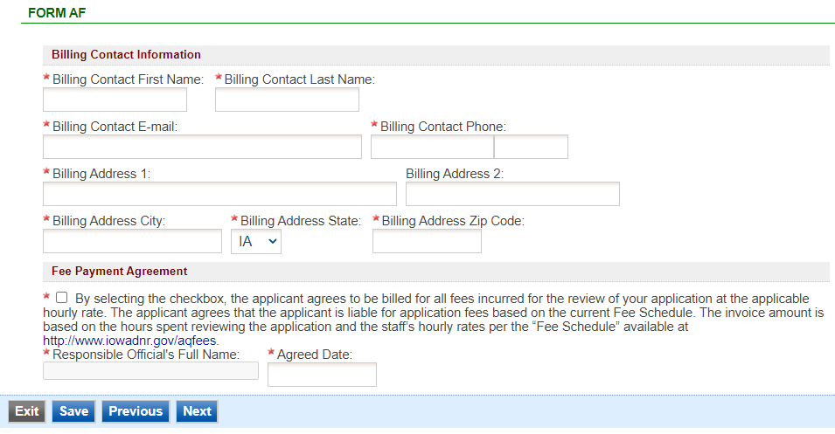

Figure 17 Form AF Screen

If this form is applicable, please enter the contact information for the person who should be contacted regarding billing for the review of the application materials. Please review the fee payment agreement carefully and check the box indicating that you agree to be billed for all fees incurred for the review of your application at the hourly rate, then enter the Responsible Official’s Full Name and date. Once you have finished entering the information, click “Save” and then “Next”. If there is required information missing from the section, the Iowa EASY Air system will highlight the required fields in red. You may proceed with the application, but the system will not allow you to submit the application until all the required fields are completed during the Validation step.

## Attachments

Next, the Attachments screen will appear (see Figure 18). Please upload the required attachments to the application and any other attachments at this screen.

Attachments may be uploaded to the application electronically, or mailed/faxed to the Department.

The Iowa DNR recommends that attachments be submitted electronically so as to not slow down the application process.

Please attach any documents required to assist the assigned engineer with completing the project on this screen, such as the plantwide baseline actual calculations (for the two years selected) as well as documentation and records on the actual emissions.

To include your attachment(s) in the Iowa EASY Air system, select the “Online” radio button and then click on the "Upload" button as shown in Figure 19. Only one file may be uploaded at a time, and the maximum file size allowed is 100 MB. An example of the attachment screen is shown below for reference.

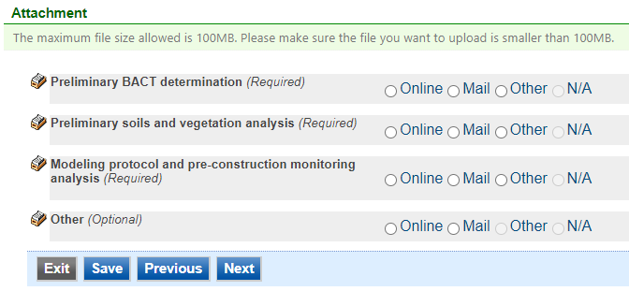

Figure 18 Attachment Screen

Select “Choose File” to select the document to be uploaded. These file types are accepted by the system:

* pdf, doc, docx, txt, xls, xlsx, cvs
* jpeg, jpg, bmp, png, gif
* xml

You may include a comment for each attachment. When you have successfully selected the document, click on “Save” to upload the attachment.

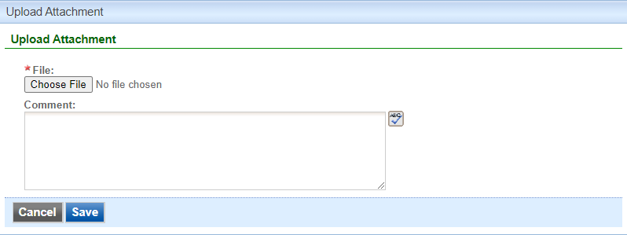

Figure 19 Attachment Screen

The uploaded attachment will display on the screen as shown in Figure 20. To remove an attachment, click the red “x” icon. The Iowa EASY Air system will confirm with you that you want to delete the record with a pop-up message. Select “Ok” on this message to confirm, or “Cancel” to stop the deletion request. To edit the attachment comment, click on the attachment comment, edit the comment, then select “Save” to update the comment or “Cancel” to cancel the change.

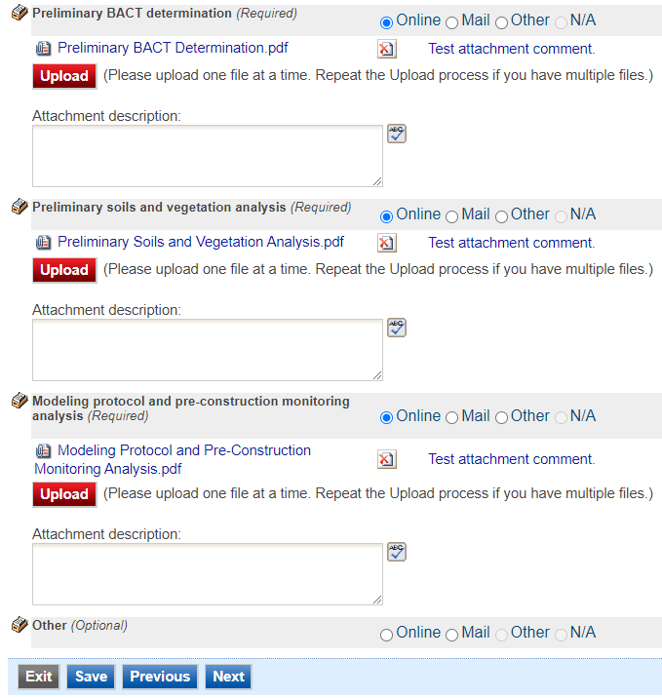

Figure 20 Example Attachment Screen

Please click “save” at the bottom of the screen to save the page.

If you do not click “save” before loading into another page, you will lose your current progress entering information.

If you plan to mail or fax the attachments, please select the “Mail” radio button on the attachment screen. If mailing attachments, include the attachment descriptions and submittal ID. Mail attachments to the following address:

Application Login Desk

Air Quality Bureau

502 E 9th Street

Des Moines, IA 50319

## Validation

Next, the Validation screen will appear (see Figure 21). The system will check the application forms for required information that is missing, and will display a result similar to the figure below:

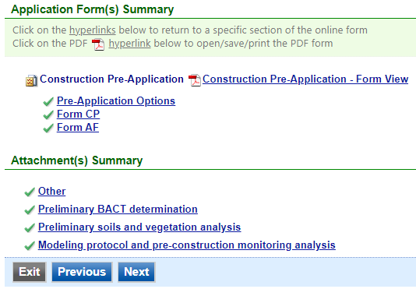

Figure 21 Example Validation Screen

If there are no noted issues, click the “Next” button. If there are issues, you may navigate to the section by selecting the section on this screen to complete the missing information.

Please note that the system will only check for missing information, and will not validate whether the information is complete or accurate.

## Submission

Next, the Certification of Submission screen will appear (see Figure 22). Please review the statement at the top of the screen, then check the box at the top of the screen, answer the security question, enter your pin, and click “Submit”.

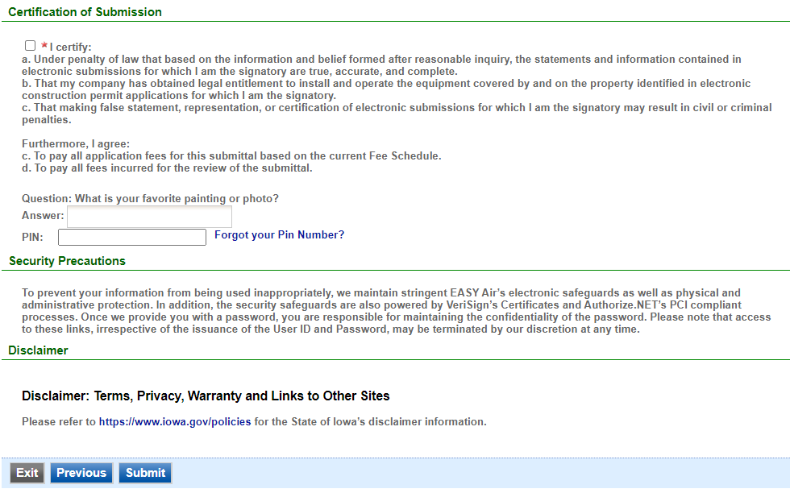

Figure 22 Example Certificate of Submission Screen

You will get a confirmation screen similar to the one shown below in Figure 23 and a confirmation email will be sent to you.

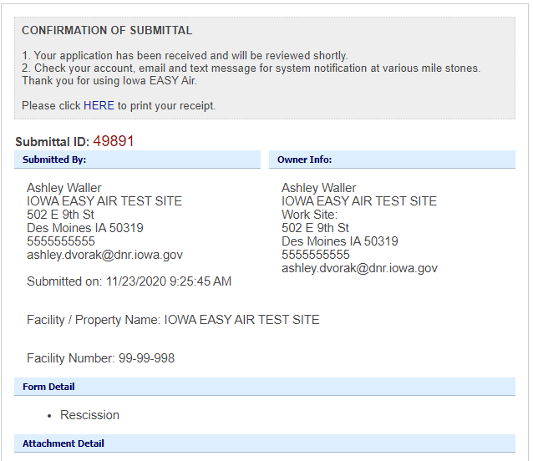

Figure 23 Confirmation of Submittal

**If you have questions, please call the Iowa EASY Air Helpdesk  
at (515) 725-9569 or (515) 204-3749.**

**Or, send an email to** [**easyair@dnr.iowa.gov**](mailto:easyair@dnr.iowa.gov)